**The Structure of the US Banking System: A Historical and Contemporary Analysis**

**(Presented By Alan Stuart K)**

**Introduction:**

The US banking system serves as the lifeblood of the nation's economy. It facilitates the flow of funds, provides access to credit, and fosters financial stability. However, the structure of this system hasn't always been what it is today. This paper delves into the historical development of the US banking system, analysing its current structure and exploring future considerations.

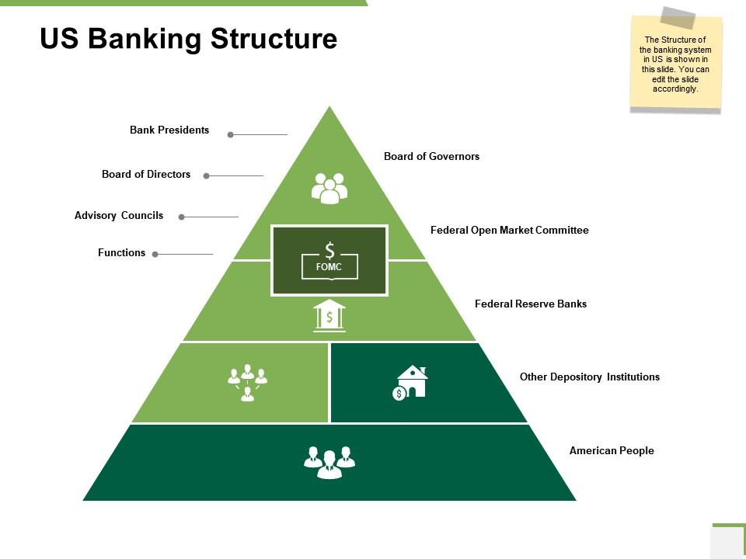

**Part 1: A Historical Evolution:**

**Early Debates and Experiments (1780s-1860s):**

The birth of the US banking system was marked by a fundamental philosophical debate. Alexander Hamilton, the first Secretary of the Treasury, envisioned a central bank modelled after the Bank of England. This institution, in his view, would manage the national debt, issue currency, and promote economic stability. However, Thomas Jefferson and other Democratic-Republicans opposed a powerful central bank, fearing concentrated economic control and favouritism towards the wealthy. They advocated for a decentralized system of state-chartered banks.

This early debate resulted in the establishment of the First Bank of the United States (1791) and the Second Bank of the United States (1816-1836). Both institutions served as central banks for their respective periods, but ultimately faced political opposition and were allowed to expire. Meanwhile, a network of state-chartered banks emerged, offering a variety of financial services but lacking uniformity in regulations and currency.

**The National Banking System (1860s):**

The outbreak of the Civil War highlighted the need for a more unified and stable banking system. The National Banking Act of 1863 established a framework for a national banking system with these key features:

* **National Banks:** The act created a system of federally chartered banks subject to regulations set by the Office of the Comptroller of the Currency (OCC).
* **Standardized Currency:** National banks issued banknotes backed by US government bonds, promoting uniformity and stability in the national currency.

**Part 2: The Rise of the Federal Reserve (1913):**

The late 19th and early 20th centuries witnessed several financial panics, periods of intense fear and loss of confidence in the banking system. These panics exposed vulnerabilities in the decentralized system and fuelled calls for reform. In response, the Federal Reserve Act of 1913 established the Federal Reserve System, the central bank of the United States.

The Fed's primary functions include:

* **Monetary Policy:** The Fed influences interest rates and the money supply to promote economic stability, full employment, and moderate inflation.
* **Bank Regulation:** The Fed supervises and regulates banks to maintain financial stability and protect consumers.
* **Financial Services to the Government:** The Fed acts as the banker for the US government, managing its accounts and issuing US currency.

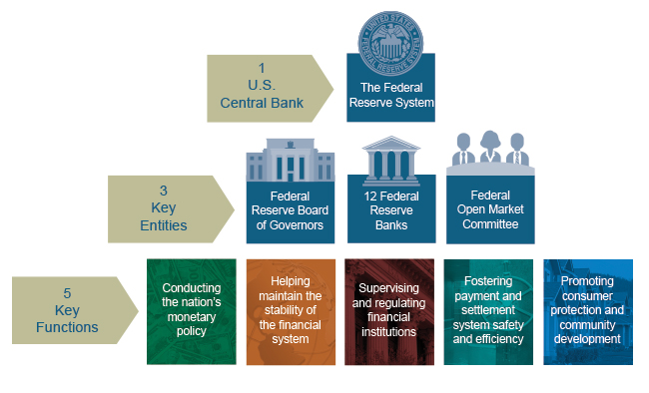

**Part 3: The Regulatory Landscape:**

The US banking system operates within a framework of regulations aimed at ensuring stability and consumer protection. Key regulatory agencies include:

* **Federal Deposit Insurance Corporation (FDIC):** The FDIC insures deposits up to a specific limit, protecting consumers in case of bank failures.
* **National Credit Union Administration (NCUA):** The NCUA oversees credit unions, which are non-profit financial institutions owned by their members.
* **Consumer Financial Protection Bureau (CFPB):** The CFPB protects consumers in financial transactions by setting regulations and enforcing fair lending practices.

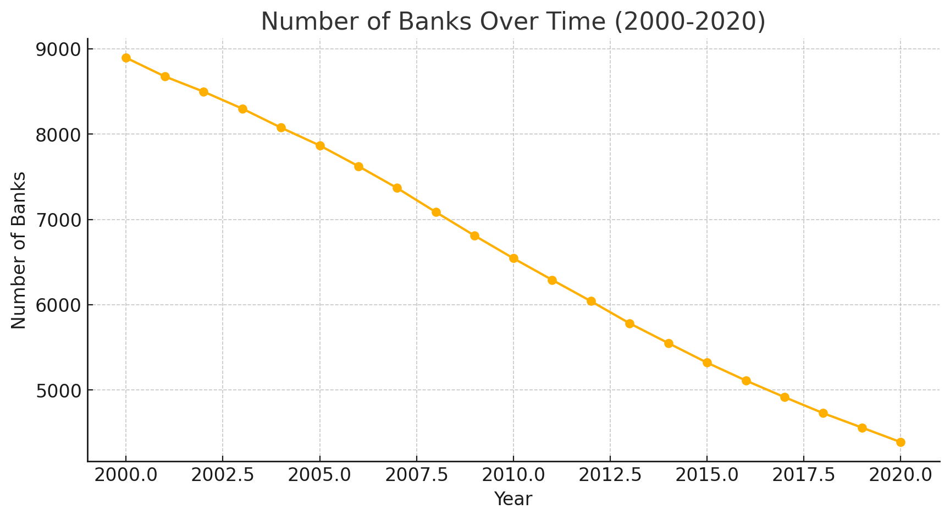

**Part 4: A Mosaic of Institutions:**

The US banking system offers a diverse range of institutions catering to different needs and financial activities. Here's a breakdown of some key types:

* **Commercial Banks:** These are the most common type of bank, accepting deposits, offering loans and other financial services such as checking and savings accounts, and playing a crucial role in business lending.

**Investment Banks:** Investment banks specialize in raising capital for businesses and governments through underwriting and selling securities. They also provide financial advisory services for mergers and acquisitions.

* **Credit Unions:** Credit unions are non-profit financial institutions owned by their members. They offer similar services to commercial banks, but typically focus on serving specific communities or groups and may offer lower interest rates on loans and higher returns on savings accounts.
* **Community Banks:** Community banks are smaller financial institutions with a strong focus on serving the needs of their local communities. They often offer personalized services and may specialize in lending to small businesses and individuals.
* **Savings and Loan Associations (S&Ls):** Traditionally, S&Ls focused on providing mortgages and accepting savings deposits. However, due to deregulation and financial crises, many S&Ls have converted to commercial banks or merged with other institutions.

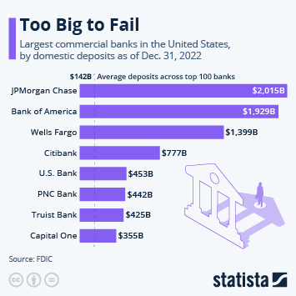

**Part 5: The Future Landscape:**

The US banking system is constantly evolving, adapting to technological advancements and changing consumer preferences. Here are some key trends shaping the future landscape:

* **Fintech (Financial Technology):** Fintech companies are disrupting traditional banking models by offering innovative financial services through digital platforms. This includes mobile banking apps, online payment solutions, and peer-to-peer lending platforms.
* **Cybersecurity Challenges:** As financial services become increasingly digital, cybersecurity threats become a growing concern. Banks and other financial institutions need to invest in robust security measures to protect customer data and prevent cyberattacks.
* **Open Banking:** Open banking allows customers to share their financial data with third-party applications and services securely. This can lead to more personalized financial products and services, but also raises privacy concerns.
* **Blockchain Technology:** Blockchain technology has the potential to revolutionize the financial industry by creating a secure and transparent way to conduct transactions. Potential applications include faster and more efficient cross-border payments, improved trade finance, and new forms of digital assets.

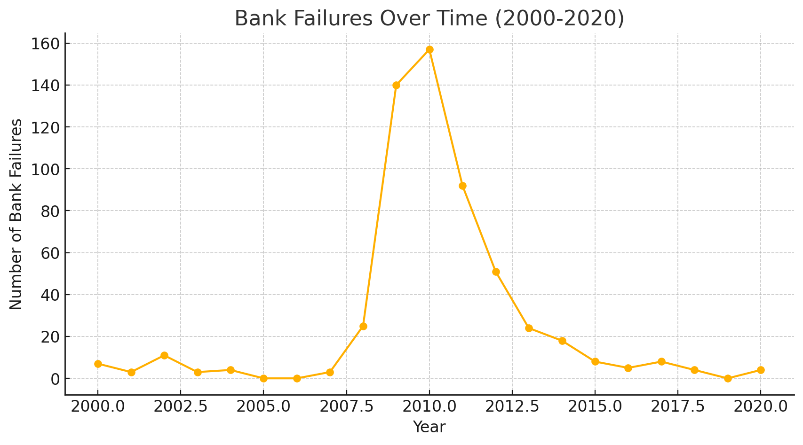

**Conclusion:**

The US banking system is a complex and dynamic entity with a rich history. From the early debates between Hamilton and Jefferson to the rise of the Federal Reserve and the emergence of Fintech, the system has continuously adapted to meet the nation's needs. Looking ahead, technological advancements and evolving consumer behaviour will undoubtedly shape the future of banking. Ensuring a stable, secure, and inclusive banking system remains crucial for maintaining a healthy and thriving US economy.

